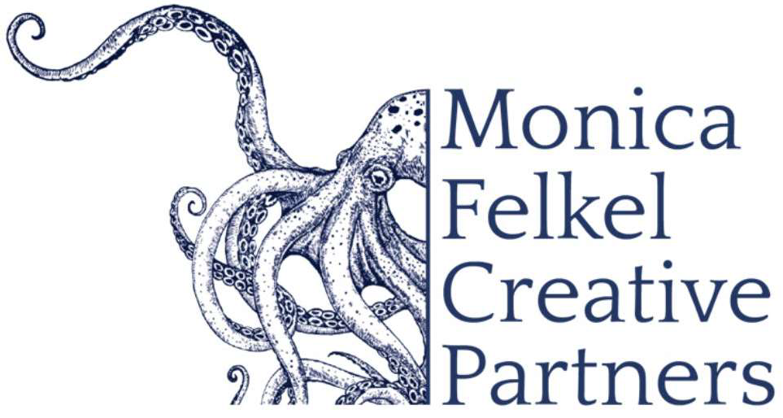
www.monicafelkelcreativepartners.com

Nokuthula Ngwenyama, viola

Performance Repertoire Offerings

Nokuthula Ngwenyama Concerto for viola and orchestra (string orchestra, harp and percussion)
commission + world premiere opportunity (22’)

Nokuthula Ngwenyama Sonoran Storm (last movement) (9’)
Recording of the Janacek Philharmonic, Anthony Armore, conducting
https://on.soundcloud.com/vsGb5uayqfzcsPeW8

Nokuthula Ngwenyama A Bishop’s Processional for violin and string orchestra (5’)
Janaček Philharmonic, Anthony Armore conducting https://on.soundcloud.com/vSuxfqiFupHEAj957

(Violin and piano version performed by Melissa White at the Phillips Collection,
will be performed 24-25 season with Philadelphia Chamber Music Society)

Alan Hovhaness Talin Concerto for viola and string orchestra

W.A.Mozart Symphonia Concertante

Krzysztof Penderecki Concerto for viola and orchestra

Dobrinka Tabakova Suite in Old Style for viola and chamber orchestra

